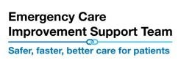
  This tool is to be used after a decision has been made to admit the patient to ensure all options are considered
NEWS2 flow chart – Admission Decision support tool
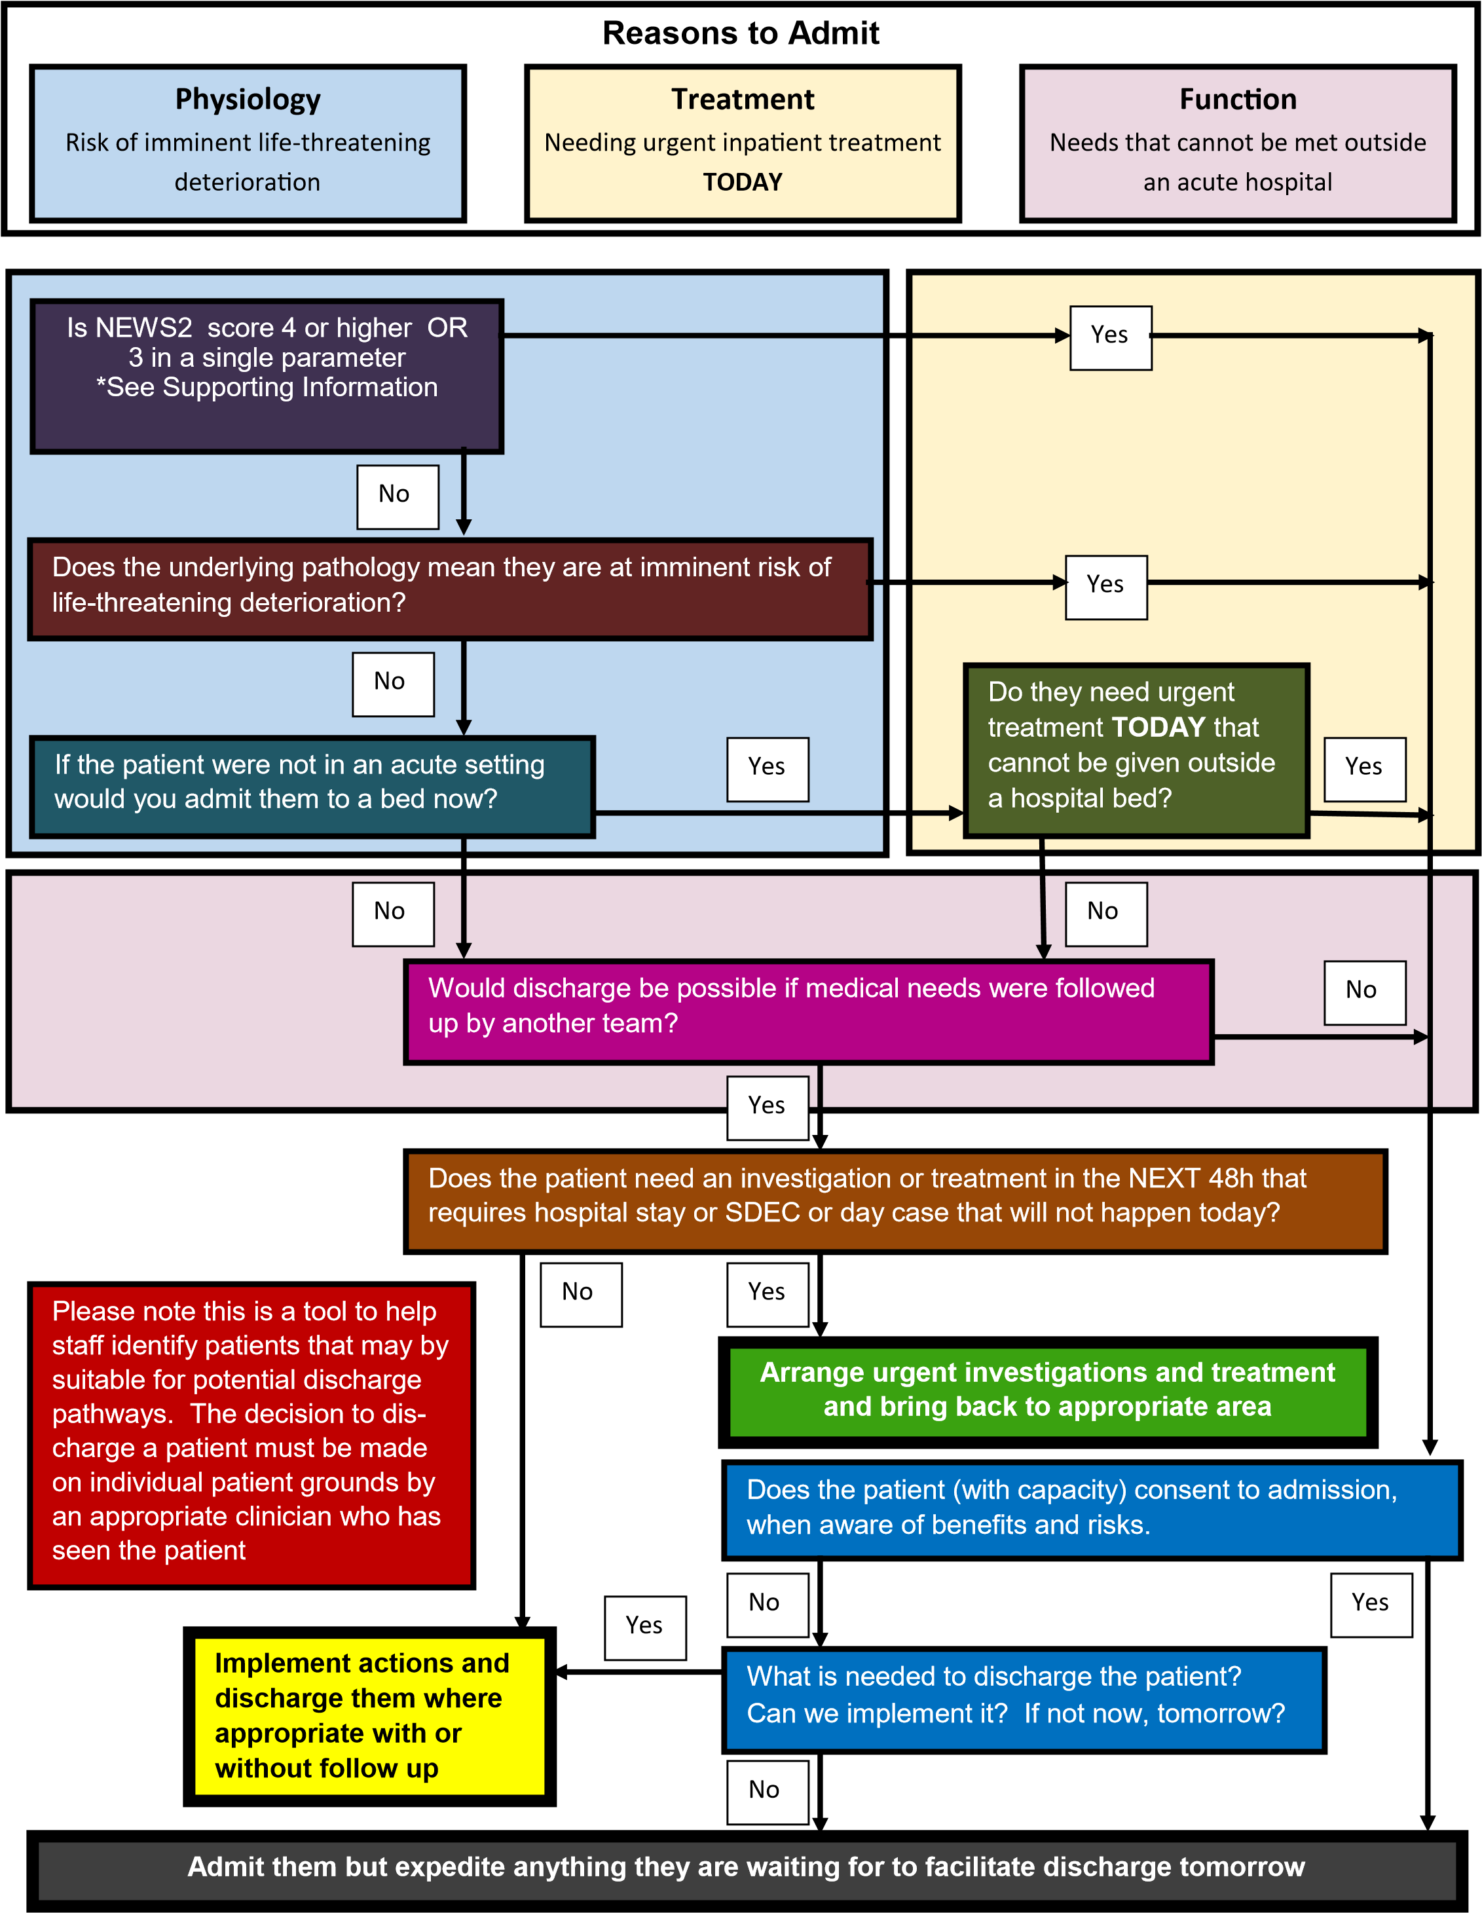
Supporting information
Is the NEWS2 Score 4 or higher OR 3 in one parameter after treatment?
Example:
Heart rate130 after treatment
This only applies to changes in physiology. It is normal for some people to be confused or to require long-term oxygen
Mild delirium can be managed via SDEC and D2A pathway 1, with or without family support. Raised temperature alone is not a reason to admit
Does the underlying pathology mean they are at imminent risk of life-threatening deterioration?
Examples:
Sudden vascular deterioration (Life-threatening ischaemia, infarction or haemorrhage of any major body part), severe metabolic disorders, Rapidly progressive conditions Apply validated disease-specific risk scoring if available
If the patient were not in an acute setting now would you admit them to a bed now?
If you were seeing the patient in primary care or an outpatient clinic
Do they need urgent treatment TODAY that cannot be given outside a hospital bed?
Examples:
Surgery, Chest drain, High flow oxygen
Would discharge be possible if medical needs were followed up by another team?
Examples:
2WW clinic, Hot clinic, SDEC, Frailty assessment
Palliative care needs that cannot be met elsewhere may require admission
Discharge may not be possible for certain people at particular times (e.g. frail older people in middle of night)
Does the patient need an investigation or treatment in the NEXT 48h that requires hospital stay or SDEC or day case that will not happen today? (iv)
Examples:
Fracture for ORIF, Pleural effusion requiring investigation and / or drainage, Blood transfusion, suspected pulmonary embolus.
Patients should not be admitted for an opinion
Arrange urgent investigations and treatment and bring back to appropriate area
Examples:
Blood tests and ECG for next day surgical procedure.
Does the patient (with capacity) consent to admission, when aware of benefits and risks.
Use BRAN in your discussions and documentation.
What are the Benefits of remaining in hospital?
What are the Risks?
What are the Alternatives?
What if we do Nothing?
This tool is not designed to aid decisions on admissions of children or people with a primary mental health presentation

